Tutorial: <https://uofglasgow.zoom.us/j/95345387313>

# Week 1

## 2A: Multivariable Functions and Graphs, Surfaces

A function f set D set R is a process which assigns to each element of D a unique element of R.

* The image of *f* is (everything the function can reach)
  + Range
* The graph of *f* is graph(f)

A function has:

* domain/codomain
  + Domain D: interval for x for the function to make sense
  + Codomain R: real numbers (y-axis)
* some expression for *f*

Multivariable functions:

Graphs:

* Let f: D in R^2 to R, then graph is graph(f)=
* The graph is part of a surface
  + Not all surfaces are graphs of a function

Surface for some function F(x,y,z)

* If then

## 2A: Cross Sections and Level Curves, Partial Differentiation

Surfaces expressed with F(x,y,z) = 0

Cross section – the intersection between the surface and a plane

Level curve

* related to the intersection of the surface with the planes
* in the domain

### Partial differentiation

* This is the slope of the tangent to the graph at (a, g(a))

Two variables:

* f:   
  (
* Fix , then   
  Fix , then
* The partial x-derivative of f at (a,b) is
* The partial y-derivative of f at (a,b) is

General case: variables part. der.

Partial derivatives **do not always exist**

* In this course, all examples will have derivatives that exist

Def: Suppose f is a suitably well-behaved function of variables . Then at the point we have:

# Week 2

## 2A: Implicit Partial Differentiation, Higher Order Derivatives

If z(x,y) is a function of x (and y), the partial derivative with respect to x of an equation including z has to have z as z’.

If there exists a function , the partial derivative with respect to x1, is also a function of the same variables

The total number of partial derivatives taken is called the ORDER of the derivative

Simplified Clairaut’s Theorem: Under the same hypothesis the order of the derivatives is not important

## 2C: Ordered Field Axioms, Bounds

The real numbers form a *field* under addition and multiplication

* There are field axioms (distributivity, associativity, etc)
* Cancellation law:

Order axiom:

* There is a relation > on R satisfying
  + For all a , exactly one of the statements a=0, a>0, a<0 is true
  + For all a, b
  + For all a, b with a>0 and b>0, we have and

An M in real numbers is an **upper bound for a set** if and only if for all a in A we have . Define the set to be **bounded above** if and only if there exists an upper bound for the set.

An m in real numbers is a **lower bound** if and only if for all a in the set, we have

Bounded set – bounded both above and below.

* There exists a K such that

# Week 3

## 2A: Chain Rule, PDEs

Chain rule – see last week’s notes.

The matrix DF(x) consisting of partial derivatives of F in terms of partial derivatives of f and g (i,j-entry is ) is an matrix

General formula for the chain rule is

### PDEs

An equation involving functions of several variables and their partial derivatives.

Solving: integrating with respect to a variable (and treat the other variables as constants)

* ODEs: C as constant
* PDEs: c(y) as a constant function of another variable

## 2A: Solutions to PDEs

General solution algorithm:

1. var x, y u=u(x,y) and v=v(x,y) (in this course, these will be given)
2. Compare with Chain Rule:

# Week 4

## 2A: Double Integration Over Rectangular Domains, Domain Types

Meaning of integration (1 variable) – the (signed) area below a graph (if below x, negative)

Double integral – volume below a graph

When domain is a rectangle (a to b in x axis, c to d in y axis ):

* (iterated integrals)

Types:

* Type I domain – the cross section parallel to y is a line/point
  + Fixed x
* Type II domain – the cross section parallel to x is a line/point
  + Fixed y
* Can be both/neither
  + If neither (e.g. a donut), can be divided into parts for disjoint union of them
* Regular domain – domain which can be written as a disjoint union of a finite number of type I/II regions

## 2A: Integrals Over Type I/II Domains

Type I:

Type II:

**CONSTANTS OUTSIDE, FUNCTIONS INSIDE**

# Week 5

## 2A: Polar Coordinates

Instead of (x,y), it’s r (length) and theta (angle)

When to use polar coords:

* D’ is simpler to describe (circular symmetry)
* Function is simpler to describe

Lemma (aside): if and

## 2A: General Change of Variables in 2 Dimensions

If

* To understand:
  + area

Aside: area of parallelogram with sides **a, b** is (column vectors)

* The matrix is called the Jacobian (also sometimes the determinant is called that)

The ratio of is

Useful:

# Week 6

## 2A: Triple Integrals

Volume of a 4d object (domain V)

Use in physics: If f(x,y,z) is the density of an object, the triple integral gives the mass of the region V

When z is bounded by u(x,y) (top) and v(x,y) (bottom), look at projection D in the xy plane. for every.

When y is bounded, project to xz plane. for every

In general, suppose there is an order of (x,y,z), say z,x,y, such that V can be described as follows

Then

## 2A: Change of Variables in 3-Integrals and Spherical Coordinates

where

Spherical coordinates:

* r – distance from origin to point
* – angle between positive z axis and line joining origin and point
* – angle between positive x axis and projection of r in xy plane
* Properties
* Intervals
* Change of variables for spherical coordinates:

# Week 7

## 2A: Scalar & Vector Fields, Quiver Plot, Directional Derivative

Scalar fields: functions f:

Vector fields: functions

Quiver plot: at any point (x, y), draw vector **F**(x,y) (from point in vector direction)

Gradient of a scalar field:

* Start with scalar field (f from R^n), construct a vector field
* Given such an f, there are n first order derivatives
* Def: the gradient of f is the vector field
  + (nabla) – denotes a Phoenician harp in Greek

Directional derivatives

* Computer partial derivatives of f with respect to any direction
  + Direction – any vector in R^n of length 1
* The directional derivative of f in the direction evaluated at a point is

where i and j are unit vectors.

Theorem:

* Proof:
  + Define
  + Compute F’ in 2 different ways:
    - 1:
    - 2:
    - By chain rule

## 2A: Maximal Rate of Change, Divergence of a Vector Field

Given function f and point P. Q1: In which direction does f change fastest? Q2: What is the value of this maximum change?

Theorem:

* f is a differentiable function such that The maximum value of is . It occurs when **u** is in the same direction as .

Divergence of a Vector Field:

div(F) :=

* Def: div(F) is a scalar field

div > 0: expanding  
div < 0: converging  
div = 0: F is incompressible

# Week 8

## 2A: Laplacian, Curl

Laplacian:

* The divergence of a gradient of a scalar field
* Different notation
* If f is such that then f is called harmonic

Curl:

* Only defined for
* Describes rotation around axes
  + Positive constant – anti-clockwise rotation
  + Negative constant – clockwise rotation
  + If the curl is ***0***, **F** is called irrotational/curl-free

## 2A: Nabla Identities

Properties of grad, div, curl

* Sum:
  + grad(a+b) = grad(a) + grad(b)
  + div(a+b) = div(a) + div(b)
  + curl(a+b) = curl(a) + curl(b)
* Constant:
  + grad(cf) = c*grad(f)
  + div(cF) = c*div(F)
* Product:

# Week 9

## 2A: Parametric Curves, Line Integrals

Goal: define (give meaning to)

* (line integral of scalar field)
* (line integral of vector field)
* C – path of integration

Parametric description of a curve – a function

* A curve may have more than 1 parametric description
* n=2: plane curve; n=3: space curve

### Line integrals of scalar fields:

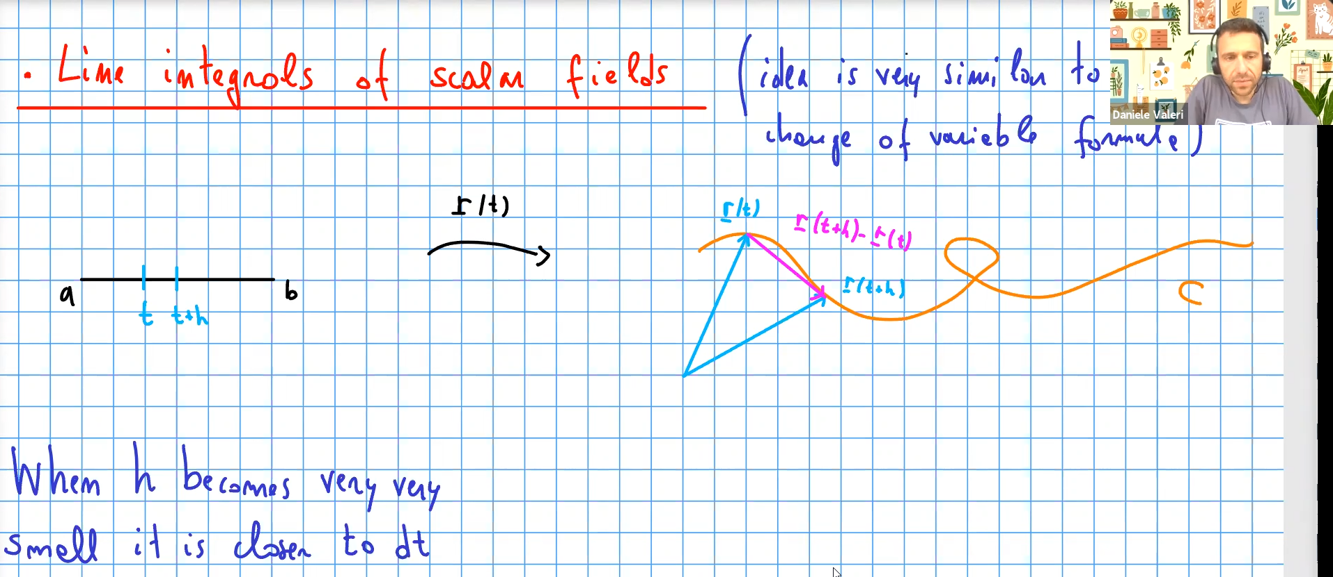

* also, when h becomes very small, is close to ds
* where and (parametrisation of C)

### Line integrals of vector fields:

* where:

Components:

Then:

## 2A: Green’s Theorem

2 components:

* Let be a vector field in R^2
* Let C be a curve that is: closed, simple, positively oriented
  + closed: start = end
  + simple: no self-crossings
  + positively oriented: anti-clockwise

Green’s Theorem:

* where A is the area enclosed by curve C

# Week 10

## Lecture 19: Conservative and Path Independent Vector Fields, Potential

**Conservative** Vector Fields:

* A vector field is **conservative** if there exists a certain scalar field such that
* The scalar field f is called a **potential**
  + Not unique: is also a potential for **F**)

Path Independent Vector Fields:

* A vector field **F** is called path independent if
* for every path from A to B.

**All conservative vector fields are path independent**

* Proof:
  + Choose a parametrisation of C: such that
  + Since **F** is conservative,
  + by the Chain Rule
  + which does not depend on C.

Remark:

Conditions for vector fields to be conservative

* If **F** is defined everywhere, continuous and path independent, then it is also conservative
* If n=2:
  + If , **F** is path independent
  + If is everywhere defined and continuous in , then **F** is **conservative** if and only if
* If n=3:
  + Let F be everywhere defined and continuous. Then **F** is conservative if and only if
    - (definition of irrotational vector field)

If **F** is conservative, how to find potential f:

* Solve a system of PDEs
* Alternative way:
  + Choose a point and choose some path from A to
  + Define
  + Then

## Lecture 20: Parametric Surfaces, Surface Integrals

Parametric Surfaces:

* A parametrised surface us a function
* Classic example:
  + Graph of function

Surface Integrals:

* 1. How to use **r**?
  2. Area spanned by two vectors in is
  3. The ratio of areas in 2D plane vs 3D spaces:

1. Formula:

# Week 11

## Lecture 21: Orientable Surfaces, Normal Vector Fields, Surface Integrals of Vector Fields

Most surfaces have:

* an exterior (upward)
* and interior (inward)

To move from one side to the other, one needs to cross some edge of the surface

**Orientable** surfaces – having two sides

* Choosing an orientation – choosing one preferred side by defining a vector field (**normal vector field**) such that
  + N(**x**) is orthogonal to the tangent plane of S at **x**,

How to find the normal vector field **N**:

1. (or its negative)
2. or
3. S is characterised by

Surface integrals for vector fields:

* A number that measures the **flux** of the vector field across the surface
* Requires choosing an orientation for the surface
  + S is an orientable surface
  + F is a vector field on S
  + dN is an orientable surface element
* Fix a parametrisation of S: and choose a normal vector field, say

## Lecture 22: Gauss Divergence Theorem

The Theorem:

V: bounded volume with surface S and outward pointing normal unit vector field **N**